Preschool-K-First Grade Second—Third Grade Fourth-Fifth Grade 6th-7th-8th Grade
A- Cowboys E- Broncos I- Seahawks L- Cowboys O- Broncos R- Raiders U- Seahawks W- Cowboys
B- Steelers F- Raiders J- Colts M- Packers P- Seahawks S- Packers V- Broncos X- Steelers
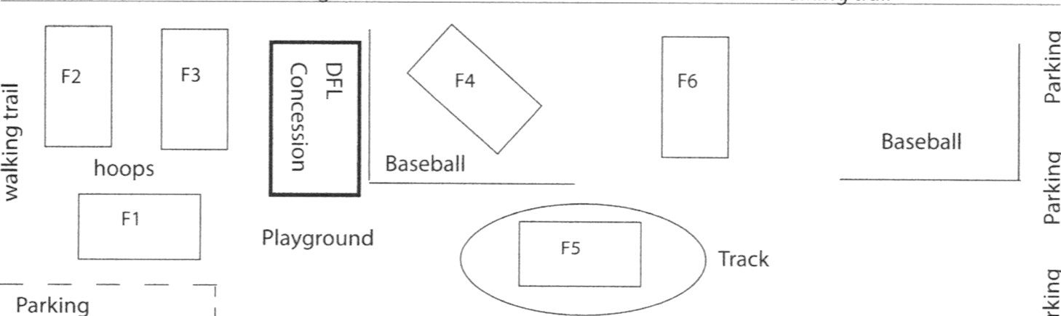
C- Packers G- Chiefs K- Broncos N- Steelers Q- Colts T- Chiefs
walking
trail
walking
trail
Parkview
Elem
Dillon
Middle
School
D- Colts H- Seahawks
WK 1 — Saturday, September 17  Field F1 F2 F3 F4 F5 F6  9 AM AvH  10 AM BvG IvN KvL PvS  11 AM CvF JvM OvR QvT VvW  NOON DvE UvX  WK 3 — Saturday, October 1  Field F1 F2 F3 F4 F5 F6  9 AM EvF  10 AM AvD NvK LvJ PvR  11 AM BvC MvI SvQ OvT UvW  NOON GvH VvX  WK 5 — Saturday, October 15  Field F1 F2 F3 F4 F5 F6  9 AM TBD TBD TBD TBD TBD  10 AM TBD TBD TBD TBD TBD  11 AM TBD TBD TBD TBD TBD  NOON TBD TBD TBD TBD TBD  FYI: School District #10 is tobacco free, and no dogs are allowed on school grounds. | WK 2 — Saturday, September 24  Field F1 F2 F3 F4 F5 F6  9 AM DvH  10 AM CvG JvK MvN RvS  11 AM BvF IvL OvQ PvT UvV  NOON AvE XvW  WK 4 — Saturday, October 8  Field F1 F2 F3 F4 F5 F6  9 AM DvF  10 AM CvA LvM KvI OvS UvX  11 AM HvB NvJ PvQ RvT VvW  NOON EvG  The Rollover Plan:  We will invoke the Rollover Plan should the weather be too cold or wet early in the day to play but may improve as the day goes on. We start our games at 10 am. If we invoke the Rollover Plan for the 10 am games, the 11 am and 12 pm games don’t change. We will simply roll the 10 am games over to 1 pm. If it is still bad, we will roll the 11 am games to 2 pm and start our day with the 12 pm games. We will simply rollover the first hour games to the end of the day and leave the rest of the schedule in place. So, don’t jump to the conclusion that all games are canceled if you go by the field and there are no games going on.  We have solid calling tree now in place with our rosters. We will call the coaches; coaches will call the players.  The lost and found will be based at or near the concession stand.

